**Problem Statement**

The goal of this assignment is to improve the provided washingdc.jpg image contrast using the histogram equalization.

**Design Approach**

Figure 1: An image showing the design approach with washdc512.jpg as the root class

**Concluding Remarks**

After performing the histogram equalization, we get the following results:

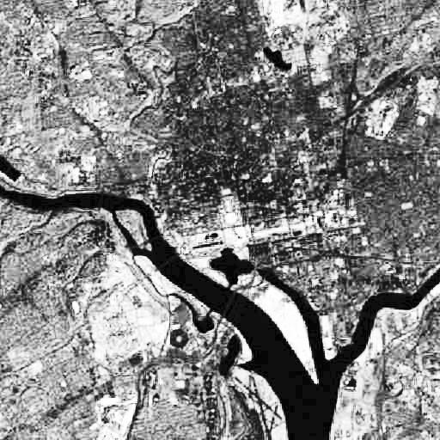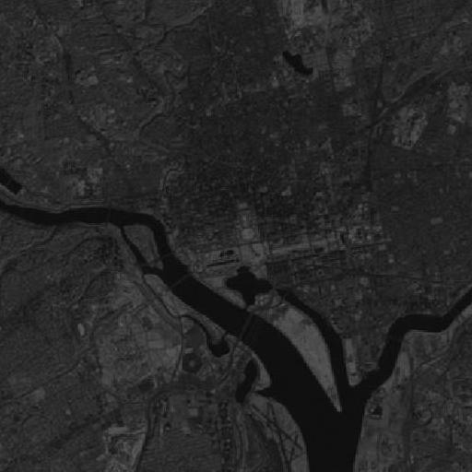

Figure 2: image on the left showing before performing histogram equalization process whereas the image on right shows after performing histogram equalization process.

After performing the histogram equalization process we can see that the image on the right has a higher contrast and is brighter and we are able to see things more clearly, where as the image on the left has intensity values and is therefore darker.